For thankful sysargv example

Python –m ptest1

Uses python module flag to indicate to run this. Searches sys.path and finds this as a module under rlbcode directory NOTE – no.py extension in this example since it’s looking for a module not a script as noted in next sentence.

If we run python ptest1.py – will find the test file you put in scripts as that is part of the windows path

********** older notes below ************

Python notes

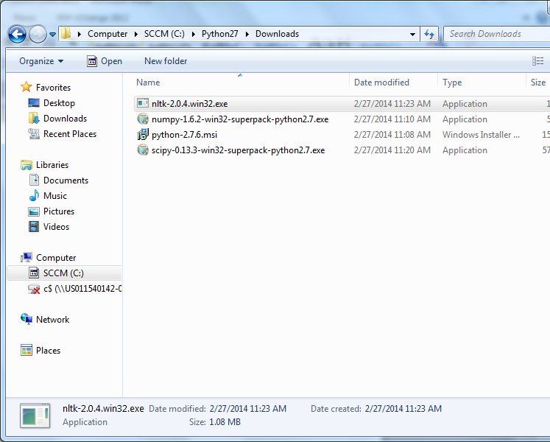

Make sure to right click and select install as administrator – especially nltk.

Try this for dateutil

cd python dateutil directory

python setup.py build

python setup.py install

Needed to easy_install python-dateutil

When you see something like __future__ remember there are 2 underscores on each side.

Also required easy_install six

Now asking for pyparsing when I import matplotlib

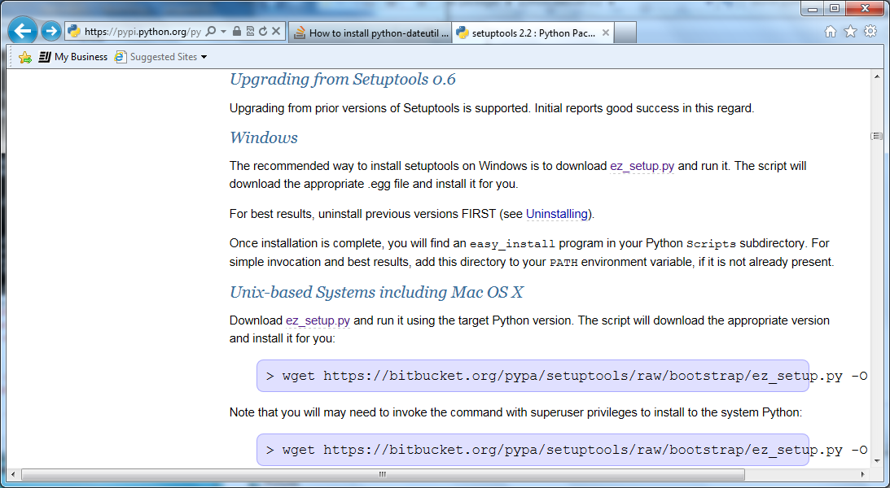don’t forget to get the easy install py script.

Python path – need to update lib\site.py

Needed to add a .pth file to site-packages to get Python to recognize my rlbcode directory in the path. Added file rlbcode.pth – worked great

Trying to install pytesser from google for ocr recognition

https://code.google.com/p/pytesser/wiki/README

Download and install pil – python image library

Easy_install pil from command prompt

Copied pytesser zip and extracted to site-lib

Added pytesser directory to the rlbscripts.pth file in site lib

Tried the examples from pytesser readme. Got errors.

HAVE TO RUN THE PYTESSER SCRIPTS FROM THE PYTESSER DIRECTORY TO MAKE THEM WORK.

Downloaded English dictionary too separately.

SAW THIS HIGHLIHGTED STUFF ONLINE TOO BUT DIDN’T TRY IT.

There's an easy work around for this if you're using the pytesser directory as a submodule (you've added an empty __init__.py file):

Change this line in pytesser.py (line 13):

tesseract_exe_name = 'tesseract'

to this:

tesseract_exe_name = os.path.dirname(__file__) + '/tesseract'

That way it will look in the correct place for the executable.

**How to Install**

1. Install [Python](http://www.python.org/download/) 2.4 or newer. (**Python 3 is not supported.**)
2. Download the [PDFMiner source](http://www.unixuser.org/~euske/python/pdfminer/index.html#source).
3. Unpack it.
4. Run setup.py to install:
5. # **python setup.py install**
6. Do the following test:
7. $ **pdf2txt.py samples/simple1.pdf**
8. Hello
9. World
10. Hello
11. World
12. H e l l o
13. W o r l d
14. H e l l o
15. W o r l d
16. Done!

This produces a text stream from the input file we may be able to work with. These flags keep the text in reasonable lines.



Pdf2txt.py –M 100.0 –L 10 –o secreq1.txt secreq.pdf

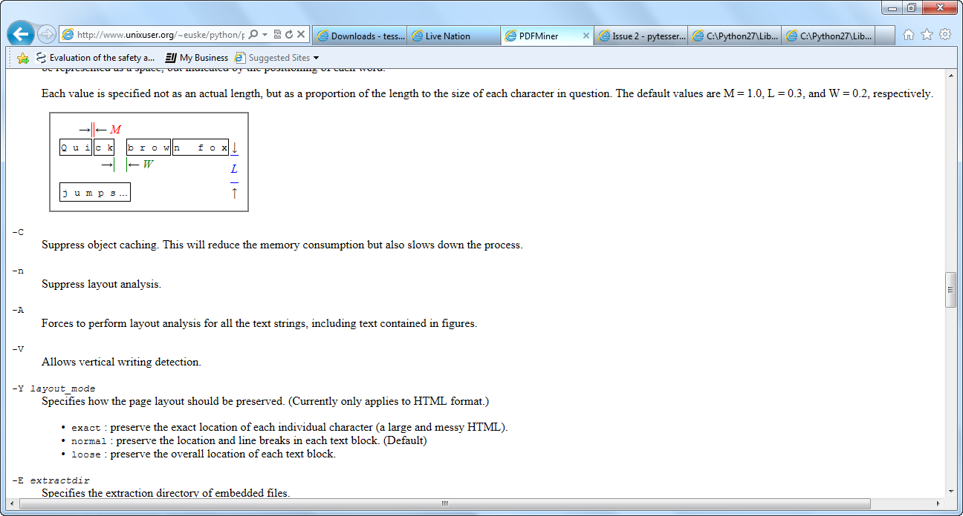

Installed xlrd easy_install xlrd to extract stuff from excel

Also xlwt and xlutils packages installed

Need a way to interact with Excel.

Xlrd – license

Pyxll – enthought

Pyinex – code.google.com – probably not – used to call python from excel.

Pywin32 on sourceforge is what we need for the book. It’s an extension.

Downloaded pywin32-218…exe from sourceforge.net and installed.

# Licensing[¶](http://cx-freeze.readthedocs.org/en/latest/license.html#licensing)

* Copyright © 2007-2013, Anthony Tuininga.
* Copyright © 2001-2006, Computronix (Canada) Ltd., Edmonton, Alberta, Canada.
* All rights reserved.

NOTE: this license is derived from the Python Software Foundation License which can be found at <http://www.python.org/psf/license>

## License for cx_Freeze 4.3.2[¶](http://cx-freeze.readthedocs.org/en/latest/license.html#license-for-cx-freeze-4-3-2)

1. This LICENSE AGREEMENT is between the copyright holders and the Individual or Organization (“Licensee”) accessing and otherwise using cx_Freeze software in source or binary form and its associated documentation.
2. Subject to the terms and conditions of this License Agreement, the copyright holders hereby grant Licensee a nonexclusive, royalty-free, world-wide license to reproduce, analyze, test, perform and/or display publicly, prepare derivative works, distribute, and otherwise use cx_Freeze alone or in any derivative version, provided, however, that this License Agreement and this notice of copyright are retained in cx_Freeze alone or in any derivative version prepared by Licensee.
3. In the event Licensee prepares a derivative work that is based on or incorporates cx_Freeze or any part thereof, and wants to make the derivative work available to others as provided herein, then Licensee hereby agrees to include in any such work a brief summary of the changes made to cx_Freeze.
4. The copyright holders are making cx_Freeze available to Licensee on an“AS IS” basis. THE COPYRIGHT HOLDERS MAKE NO REPRESENTATIONS OR WARRANTIES, EXPRESS OR IMPLIED. BY WAY OF EXAMPLE, BUT NOT LIMITATION, THE COPYRIGHT HOLDERS MAKE NO AND DISCLAIM ANY REPRESENTATION OR WARRANTY OF MERCHANTABILITY OR FITNESS FOR ANY PARTICULAR PURPOSE OR THAT THE USE OF CX_FREEZE WILL NOT INFRINGE ANY THIRD PARTY RIGHTS.
5. THE COPYRIGHT HOLDERS SHALL NOT BE LIABLE TO LICENSEE OR ANY OTHER USERS OF CX_FREEZE FOR ANY INCIDENTAL, SPECIAL, OR CONSEQUENTIAL DAMAGES OR LOSS AS A RESULT OF MODIFYING, DISTRIBUTING, OR OTHERWISE USING CX_FREEZE, OR ANY DERIVATIVE THEREOF, EVEN IF ADVISED OF THE POSSIBILITY THEREOF.
6. This License Agreement will automatically terminate upon a material breach of its terms and conditions.
7. Nothing in this License Agreement shall be deemed to create any relationship of agency, partnership, or joint venture between the copyright holders and Licensee. This License Agreement does not grant permission to use copyright holder’s trademarks or trade name in a trademark sense to endorse or promote products or services of Licensee, or any third party.
8. By copying, installing or otherwise using cx_Freeze, Licensee agrees to be bound by the terms and conditions of this License Agreement.

Computronix® is a registered trademark of Computronix (Canada) Ltd.

[Previous](http://cx-freeze.readthedocs.org/en/latest/development/code_layout.html)

© Copyright 2013, Anthony Tuininga.

[Sphinx theme](https://github.com/snide/sphinx_rtd_theme) provided by [Read the Docs](https://readthedocs.org)

Read the Docs v: latest

Versions

[**latest**](http://cx-freeze.readthedocs.org/en/latest/)

Downloads

[PDF](https://media.readthedocs.org/pdf/cx_freeze/latest/cx_freeze.pdf)

[HTML](https://media.readthedocs.org/htmlzip/cx_freeze/latest/cx_freeze.zip)

[Epub](https://media.readthedocs.org/epub/cx_freeze/latest/cx_freeze.epub)

On Read the Docs

[Project Home](http://readthedocs.org/projects/cx_freeze/?fromdocs=cx_freeze)

[Builds](http://readthedocs.org/builds/cx_freeze/?fromdocs=cx_freeze)

[Downloads](http://readthedocs.org/projects/cx_freeze/downloads/)

On Bitbucket

[Edit](https://bitbucket.org/anthony_tuininga/cx_freeze/src/default/doc/license.rst)

Free document hosting provided by [Read the Docs](https://readthedocs.org). Support us on [Gittip](https://www.gittip.com/readthedocs/).

Downloaded CXFreeze and installed to try and make an executable to send to Casey

Python License (Python-2.0)



Python License, Version 2 (Python-2.0)

PYTHON SOFTWARE FOUNDATION LICENSE VERSION 2  
--------------------------------------------

1. This LICENSE AGREEMENT is between the Python Software Foundation  
("PSF"), and the Individual or Organization ("Licensee") accessing and  
otherwise using this software ("Python") in source or binary form and  
its associated documentation.

2. Subject to the terms and conditions of this License Agreement, PSF  
hereby grants Licensee a nonexclusive, royalty-free, world-wide  
license to reproduce, analyze, test, perform and/or display publicly,  
prepare derivative works, distribute, and otherwise use Python  
alone or in any derivative version, provided, however, that PSF's  
License Agreement and PSF's notice of copyright, i.e., "Copyright (c)  
2001, 2002, 2003, 2004, 2005, 2006 Python Software Foundation; All Rights  
Reserved" are retained in Python alone or in any derivative version  
prepared by Licensee.

3. In the event Licensee prepares a derivative work that is based on  
or incorporates Python or any part thereof, and wants to make  
the derivative work available to others as provided herein, then  
Licensee hereby agrees to include in any such work a brief summary of  
the changes made to Python.

4. PSF is making Python available to Licensee on an "AS IS"  
basis. PSF MAKES NO REPRESENTATIONS OR WARRANTIES, EXPRESS OR  
IMPLIED. BY WAY OF EXAMPLE, BUT NOT LIMITATION, PSF MAKES NO AND  
DISCLAIMS ANY REPRESENTATION OR WARRANTY OF MERCHANTABILITY OR FITNESS  
FOR ANY PARTICULAR PURPOSE OR THAT THE USE OF PYTHON WILL NOT  
INFRINGE ANY THIRD PARTY RIGHTS.

5. PSF SHALL NOT BE LIABLE TO LICENSEE OR ANY OTHER USERS OF PYTHON  
FOR ANY INCIDENTAL, SPECIAL, OR CONSEQUENTIAL DAMAGES OR LOSS AS  
A RESULT OF MODIFYING, DISTRIBUTING, OR OTHERWISE USING PYTHON,  
OR ANY DERIVATIVE THEREOF, EVEN IF ADVISED OF THE POSSIBILITY THEREOF.

6. This License Agreement will automatically terminate upon a material  
breach of its terms and conditions.

7. Nothing in this License Agreement shall be deemed to create any  
relationship of agency, partnership, or joint venture between PSF and  
Licensee. This License Agreement does not grant permission to use PSF  
trademarks or trade name in a trademark sense to endorse or promote  
products or services of Licensee, or any third party.

8. By copying, installing or otherwise using Python, Licensee  
agrees to be bound by the terms and conditions of this License  
Agreement.

## Microsoft Visual C++ Redistributable Package[¶](http://cx-freeze.readthedocs.org/en/latest/faq.html#microsoft-visual-c-redistributable-package)

Python on Windows requires the Microsoft Visual C++ Redistributable Package. Python 2.6-3.2 uses the 2008 version, and because of how this is installed, cx_Freeze doesn’t automatically copy it for your application. It’s also not clear whether everyone has the right to redistribute the DLLs. You’re responsible for checking the license conditions associated with the DLLs you have installed.

See CXfreeze – for more on this c++ question.

Installed PIP

Reinstalling PDFminer using PIP

pip install --pre pdfminer – install worked